FET PRACTICAL-4

**Exercise 1:**

**You are about to develop a cryptographic algorithm in which there is a need to get double the absolute difference between a given number and 13. Develop the logic in JavaScipt.**

<html>

    <head>

        <title>

            cryptographic alogorithm

        </title>

        <script>

            let number=prompt("Enter any number:");

            let new_number=Math.abs(number-13);

alert(`the absolute value is : ${new_number}`)

let final_number=new_number*2;

            alert( `the double of the absolute number is: ${final_number}`)

        </script>

    </head>

</html>

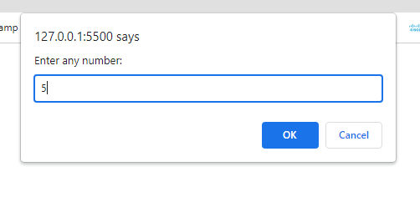

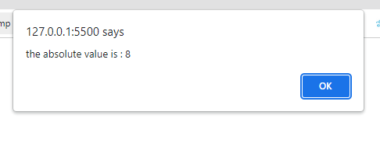

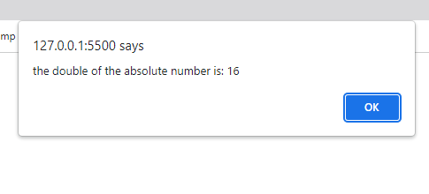

**Exercise 2:**

**A small guessing game is to be developed which takes a random integer between 1 to 5, the**

**user is then prompted to input a guess number.**

**If the user input matches with guess number, the program will display a message “Good Work” otherwise display a message “Not matched”;**

<html>

    <head>

        <title>

            question 1

        </title>

        <script>

         number=Math.floor(Math.random() * 6);

         /*alert(`Number: ${number}`);*/

         guess_number=prompt("Enter any  number from 1 to 5:");

         if(guess_number==number) {

            alert("Well Done!")

         }

         else{

            alert("Sorry wrong guess \n Better luck next time")

         }

        </script>

    </head>

</html>

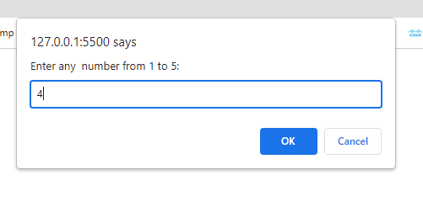

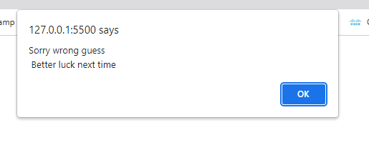

**Github link for practicals:**

https://github.com/JoshiPrarthi/FET-PRACTICAL